Motorized Trail Ambassador



2018 Program Guide

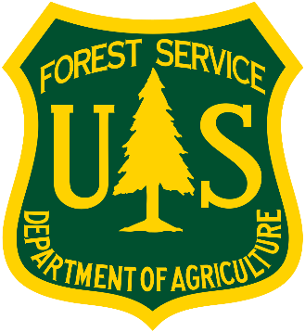

**Overview**

Thank you for expressing an interest in our Trail Ambassador Program! The aim of the program is to bring community support to our local trails through a cooperative effort of the Colorado Backcountry Trail Riders’ Association (CBTRA), Rocky Mountain Sports Riders (RMSR), Colorado Parks and Wildlife and the Forest Service. The Ambassador program is important to promote responsible OHV use, help protect wildlife habitat, balance with other user groups, and ensure long-term sustainability of motorized recreation on our public lands.

With the implementation of the “Green Gate Trail” and “Mile Post 1 Trail” in 2015, objectives were set to monitor illegal trail use in order to protect big game habitat; through this new program we hope to meet those objectives and foster stewardship on our local public lands among local residents, businesses and trail enthusiasts. The presence of Ambassadors to educate OHV users will help reduce impacts of motorized recreation to sustain current and future riding opportunities.

**Role of Motorized Ambassador**

Engage the public at OHV staging areas and on motorized trails in the Basalt to Gypsum Trail system. Offer education and information / maps to trail users on why we have seasonal closures and why motorized use is restricted to established trails.

* Expectations
  + Be present in motorized area as an ambassador for 4 days from June 21st to October 9th.
  + Volunteer at the more popular trail use times, usually mornings before work, evenings after work or on weekends.
  + Submit log information within 24 hrs after event
  + Share Stay the Trail principles with trail users over the summer.

**Seasonal Trail Closure - Frequently Asked Questions**

**Where do the closures apply?**

* Basalt to Gypsum Trail system

**Trail Closures are as follows:**

Green Gate: October 10 - June 20

Mile Post 1: October 10 - June 20

North Gate: October 10 – June 20

Lone Pine: October 10 – June 20

**Why?**

* Surviving high elevation winters can cause mule deer and elk to be in a state of near starvation as spring begins.
* Spring, and the green up of vegetation that occurs with it, triggers migration from the deer and elk’s winter range areas to their calving/fawning habitat and summer ranges.
* Mule deer and elk require this new food source to put on weight and restore their overall body condition so they are able to calve/fawn and subsequently nurse their young.
* Balance the needs of multiple user groups on multiple use public land.
* Fawning and Calving occurs between the last weeks of May into the first two weeks of June. Calves and Fawns exhibit "hiding" behavior; remaining perfectly still for a number of days prior to being ambulatory enough to escape from predation or move away from disturbance. By the end of the third week of June or by July 1 new born young are capable of escaping predators and moving away from disturbance. The June 21 opening of this trail system is to allow young to reach an ambulatory phase.

**Why should trail users respect these closures?**

* Deer and elk see humans as predators. This means they will change their behavior when the encounter humans.
* They will flush from areas where they are resting or feeding (feeding themselves or their young) in response to the presence of humans and dirt bikes on the trail.
* This is especially damaging in the winter when food supplies are so limited.
* In the spring they need to regain their fat reserves to be able to recover from winter and also feed their young.
* If they are bothered frequently enough, such stress and disturbance by humans could lead elk and mule deer to abandon their critical habitat and even to abandon their young.

**How do humans affect mule deer and elk on the White River National Forest?**

* Mule deer and elk are not sensitive or endangered species on the White River NF.
* Their habitat has been reduced in the Eagle River Valley over time. Many factors have influenced this habitat reduction, including:
  + Development of infrastructure such as housing, roads, Interstate 70, commercial property, golf courses, playgrounds, parking areas, etc.
* Recreation uses have also played a role in habitat reduction or how the animals use the existing habitat:
  + Trails, roads, campgrounds, parking areas, ski areas all put pressure on the deer and elk’s use of the habitat they require to be successful.

**What are some ways you can reduce your impact to wildlife?**

* + Don’t feed, approach, or harass wildlife
  + Give wildlife distance when you see them on the trail – at least 100 yards!
  + If an animal changes its behavior – you’re too close – back away
    - Looks at you
    - Gets up
    - Walks, flies, or runs away
  + Always give the animal an escape route
  + Leave young wildlife alone
  + If you see sick or injured wildlife, call CPW
  + Practice leave-no trace ethics (i.e., pack it in – pack it out, and leave the area better than how you found it)

**Program Contacts**

|  |  |  |  |
| --- | --- | --- | --- |
| **Name** | **Position** | **Phone #** | **Email** |
| Trish Barrere | OHV Crew Lead |  | patriciabarrere@fs.fed.us |
| Brendan Kelly | Developed/ Dispersed Recreation Manager | (970) 827-5151 | btkelly@fs.fed.us |
| Shelly Grail Braudis | Aspen Sopris Recreation Staff | (970) 404-3155 | sgrail@fs.fed.us |
| Jen Prusse | FS Wildlife Biologist | (970) 827- 5160 | prusse@fs.fed.us |

**Documentation**

Please document your participation in the Ambassador program within 24 hours of activity. Please input your data into our digital log system at: <https://drive.google.com/open?id=1EPdXWE2LHRTtmdWyg2o4iw9SMiQuzVtVclRhVVsI0Z8>.

Printable field logs to guide your field date collection are available at: <https://drive.google.com/open?id=18Z80eF8QDxJenbZS4wAEG6qV07xiCL3oAsYRdbB6KjA>.

The electronic version of this ambassador packet will allow you to click on the above links to connect to the files. If you don’t have access to a computer you can submit the paper logs to Robbie Gregg rbgregg@fs.fed.us, the OHV crew lead.

The log has about 10 questions to answer.  When you are done, hit the SUBMIT button at the bottom!

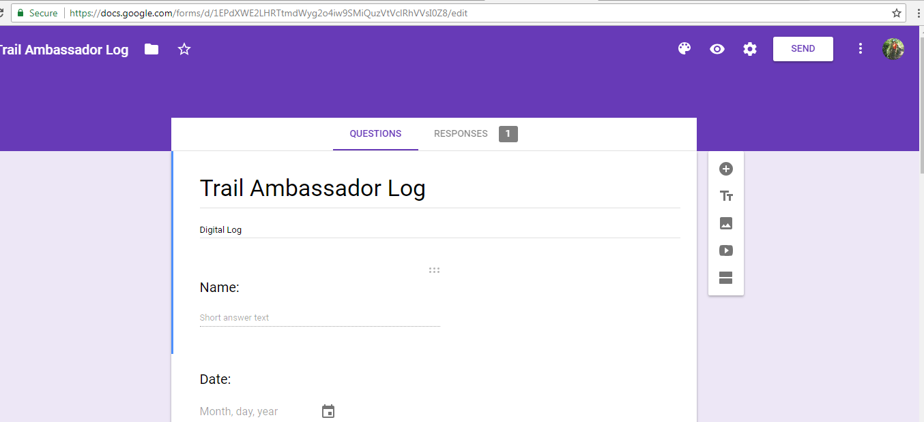

**OHV Regulations**

**Forest Service Travel Management**

Motorized vehicles are required by federal law (CFR 261.13) to ride on designated routes only. Just because something looks like a trail and there isn’t a closed sign doesn’t mean it is open for motorized travel. Motor Vehicle Use Maps (MVUMs) are produced for each ranger district on the White River NF that identify all open motorized routes, their open season dates, and what vehicles are allowed. It is the responsibility of the OHV user to know where they can and can’t ride. This information is important for the Ambassador to know and pass along to other OHV users.

MVUMs are free resources that can be obtained at any district office, online on the White River NF website or from local shops; Eagle Pharmacy, Sylvan Lake State, KTM of Aspen or Moto Source. MVUMs can also be downloaded on the free smart phone map application Avenza. Avenza will show real time location on the MVUM using GPS not requiring cell reception.

**OHV Registrations**

All Off-Highway Vehicles being used or staged on public land are required to have a current Colorado OHV Registration. Colorado Parks and Wildlife (CPW) issues registrations through their website or several retailers. Local Retailers include Walmart (Avon), Eagle Pharmacy (Eagle), and The Clinic (Minturn). User must have current sticker attached to their machine or proof of purchase, if they haven’t received their sticker yet.

* In-State Registrations, cost $25.25
  + Valid through March 31st of displayed year, so during summer months the valid registrations will display the following year. I.E. summer 2018 season will need 2019 stickers.
  + Colors change year to year
  + Registrations need to be purchased within 30 days of machine purchase date. Bill of sale will suffice up to 30 days.
  + Licensed dirtbikes being used for recreation on FS lands, as opposed to travel, should have OHV registration
* Out-of-State Permits, cost $25.25
  + Sticker or CPW tags

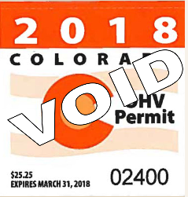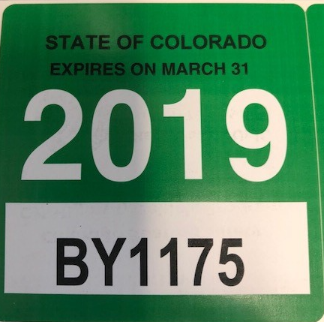

**Tread Lightly**

The LNT message for motorized recreational users is encapsulated in the *Tread Lightly* campaign. The modes of transportation covered by Tread Lightly include:  
    **OHV** - Off Highway Vehicles  
    **ATV** - All Terrain Vehicles  
    **4WD** - Four Wheel Drives  
    **PWC** - Personal Water Craft   
    **Snowmobiles**  
    **Mountain Bikes**

The Tread Lightly principles:

* **Travel and recreate with minimum impact** 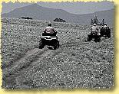
  + Travel on designated routes or areas only.
  + Travel only in areas that are open to your type of recreation.
  + Motorized and mechanized vehicles are not allowed in designated Wilderness areas. This includes ATVs, OHMs, 4WDs, Mountain Bikes, Snowmobiles, and PWCs.
  + Don’t create new routes, expand existing trails, or cut switchbacks.
  + Avoid sensitive habitats like wetlands, meadows, shorelines and tundra. These areas are easily damaged affecting wildlife, water quality, and aesthetics.
  + Cross streams at designated fords, crossing slowly at a 90-degree angle to minimize damage.
  + Go through or over obstacles such as mud, rocks, or trees. Riding around widens the trail and causes more damage.
  + Avoid muddy trails. Ride during drier times. Ease up on the gas to avoid wheel spin in soft ground.
* **Respect the environment and the rights of others** 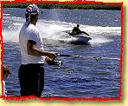
  + Respect and be considerate of other users so that all may enjoy a quality outdoor experience.
  + When driving, yield to horses, hikers, and bikers. If using watercraft, be cautious around canoes, kayaks, and other boats.
  + Respect wildlife. Be sensitive to their life-sustaining needs by keeping your distance.
  + Comply with signage.
  + Leave gates as you find them and always obtain permission to cross private land.
* **Educate yourself, plan and prepare before you go** 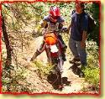
  + Know local laws and regulations.
  + Know which areas and routes are open to your type of recreation.
  + Make your trip safe. Have the right information, maps, and equipment and know how to use them.
  + If traveling by vehicle, make sure the vehicle is properly maintained and compatible with road or trail conditions.
* **Allow for future use of the outdoors, leave it better than you found it** 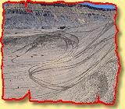
  + Take out what you bring in.
  + Properly dispose of waste.
  + Leave what you find.
  + Minimize use of fire.
  + Avoid the spread of invasive species. Clean your gear and vehicle after every trip.
  + Restore degraded areas. Volunteer your time and help local land managers.
* **Discover the rewards of responsible recreation** 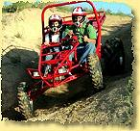
  + Do all you can to preserve the beauty and inspiring attributes of our lands and waters for yourself and future generations.
  + Outdoor recreation provides the opportunity to get away from the hustle of everyday life and builds family traditions.
  + Respect the environment and other recreationists. By using common sense and common courtesy, what is available today will be here to enjoy tomorrow.

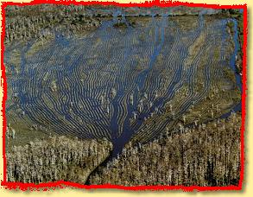

**Public Encounters**

Public contact, which will demand skill and professionalism from you, will be your primary focus while volunteering. Meeting others and making a positive impression is important as a Field Ambassador.

Meeting visitors entails incorporating a few fundamentals. Each contact you make will be different, because each individual you meet is different. Don’t expect to perform perfectly on you first day, but learn from your mistakes and make a conscious effort to improve your skills. Be creative in your contacts and share experiences with co-volunteers.

Your primary role will be **informational and educational.** Educational opportunities exist in nearly all encounters. Remember your job is to protect our resources by helping the public change its philosophy and behavior. For this reason, we stress the advantage of learning all you can about the area where you are located, the history, culture, wildlife etc.

When you meet with visitors you have only one chance to make a first impression, which will set the stage for the entire conversation. Always be courteous, friendly, tactful and neat in appearance. Your goal is positive contacts and non-confrontational conversations. Introduce yourself by name and explain what you are doing. “Hi, my name is Jill and I am a RMSR and Forest Service Volunteer Ambassador.” Sometimes it is helpful to draw them out by asking a few leading questions to find out more about them. Where are they from? Have they been here before? Giving a compliment is a good way to start a conversation. “That’s a nice backpack, what brand is it?” Be sure to listen courteously to them to see if they feel like talking. If they are not talkative, remind them of pertinent regulation or points of the message they need to know. Sometimes telling these things opens them up and sparks curiosity, giving you a chance to elaborate on *Tread Lightly* skills or other interesting tidbits.

As a volunteer, and possibly the only representative they may meet, it is critical to keep a professional, friendly manner regardless of your personal feeling. Be complete and accurate with the information you share. This does not mean conciliation where unacceptable behavior occurs. If the visitor becomes particularly difficult, withdraw and make sure to enter your observations about the encounter in your report sheet.

If you don’t know the answer to a question, please be honest with the visitor. You are not expected to know the answer to every question you are asked. If possible, offer to assist them in finding the answer by looking at a map or giving them materials that may help. You can always refer them to the Holy Cross Ranger District Office at 24747 US Hwy 24 near Minturn, phone 970-827-5715 or the Aspen – Sopris Ranger District at 620 Main St, Carbondale, phone 970-963-2266.

